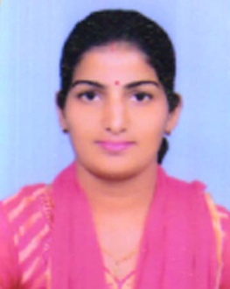
RESUME
Add – H No 563 New Shivpuri
Kila Road Khurja Bulandshahr 203131.
Mob. No – 7906579114
E-Mail – preetitanwer234@gmail.com
Education
- 2011 To 2013 – Bhagat Phool Singh Women University : Master In Law LLM (Criminology) With 1st Division.
- 2006 To 2011 – Maharshi Dayanand University : Bachelor In Law B.A. LLB(Hons) With 1st Division.
- Haryana Board of School Education: 12th from Vidya Mandir Sr.Sec. School Faridabad.
- Haryana Board of Education: 10th From Vidya Mandir Sr. Sec. School Faridabad.
Teaching Experience
- 2018 To 2019 Work Experience With Ch. Harchand Singh College of Law Affiliated With CCSU, And December 2021 to Still Work With Them.
- 2019 To 2020 Running Own Coaching Institute in Khurja Preeti’s Law Classes With Full of Efforts.
Legal Work Experience
- 2011 -: Practicing Under Professional and Senior Lawyer Mr. O.P. Sharma (Ex Member) of Enrolment Committee Haryana & Punjab High Court.
- 2013 -: 6 Month Work Experience With Law Firm In Delhi Law Associates and Others in Saket Delhi.
Executive Summary
- Passed All India Bar Exam In Feb 2014.
- Enrolled With Delhi High Court as a Advocate.
- Judicial Coaching from Rahul IAS Mukharjee Nagar 2010 to 2011.
Key Skills
- Extremely Energetic.
- Hard Working.
- Energetic Self Starter and highly Motivated.
- Ability to Adapt to the Changing Technology Environment.
- Quick Learner.
Personal Details
- Date of Birth : 30-jul-1987
- Father’s Name : Sh. Arjun Singh Tanwar
- Mother’s Name : Mrs. Radha Tanwar
- Sex : Female
- Maretal Status : Married
- Nationality : Indian
- Languages Know : Hindi, English, Haryanavi
Declaration
I hereby Declare that the above Motioned Information is true best of My Knowledge and I bear the responsibility For Correctness of the above Motioned Particulars.

Date Signature

